**2. Topology Selection**

**Linear Power Supplies**

**Advantages**

* Low electromagnetic emission problems occur.
* The transient response is at an advanced level.

**Disadvantages**

* They have low frequency operation limits.
* BJT operates in linear region, causing extra heat dissipation.
* The efficiency is achieved at low level (30% - 60% band).
* They can only step down the output voltage.

**Switching DC Power Supplies**

***Flyback Converter***

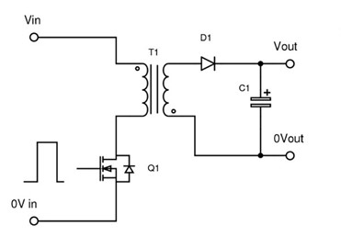

*Flyback Converter Model*

**Advantages**

* Fewer components are utilized to obtain a regulated output with respect to other switching DC power supplies. This enhances for a designer to have cost advantage and magnetic and electrical design simplicity.
* By only a single control mechanism, the regulated output is achieved.
* High voltage gain is possible to be achieved.
* It can be chosen in low power applications such as TV or PC. Since given task in this project also demands low power (96 W), it can be an effective solution.

**Disadvantages**

* Energy storage is a must for the transformer. This limits the transformer design by ferrite or air gapped cores mostly.
* It requires an additional snubber circuit if its advanced versions are not utilized (two transistor or parallel).
* A pulsating current occurs at the output side due to lack of inductance.

***Forward Converter***

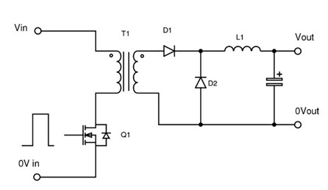

*Forward Converter Model*

**Advantages**

* The output inductor and diode ensure a continuous current flow in the output side.
* The transformer is utilized as a direct power transfer tool, not to store.
* Gapless cores can also be used leading higher Lm and fewer ripples.

**Disadvantages**

* The cost is increased with additional inductor and diode.
* The voltage stress on the switch is higher, causing higher voltage range requirement for the switches.
* Gain variety in DCM operation occurs at higher level.
* Snubber circuit implementation is needed if its practical version is not used. If practical case is chosen, then this time more transformer windings, hence more complex magnetic design process are needed.

***Push-Pull Converter***

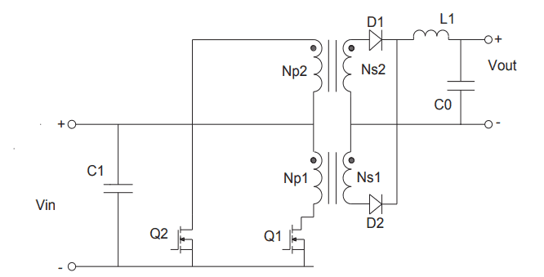

*Push-Pull Converter Model*

**Advantages**

* Utilization of the magnetic core is at more advanced stage since it can be operated not just at 1st but also in 3rd quadrant of B-H curve.
* It can properly function even at high power applications.
* Transformer rating required is usually smaller than Forward topology.
* The output is obtained without a distortion.
* DC components of the output currents at two consecutive switching periods magnetically oppose each other and the core saturation risk is reduced.

**Disadvantages**

* The switching mechanism is more complex with respect to other topologies since it requires two switches and forbids turning on simultaneously for the switches.
* The cost is increased as it needs more transformer windings and switches compared to the Flyback topology especially.
* It needs longer and more detailed magnetic design phase due to increased number of transformer windings compared to both Flyback and Forward topologies.